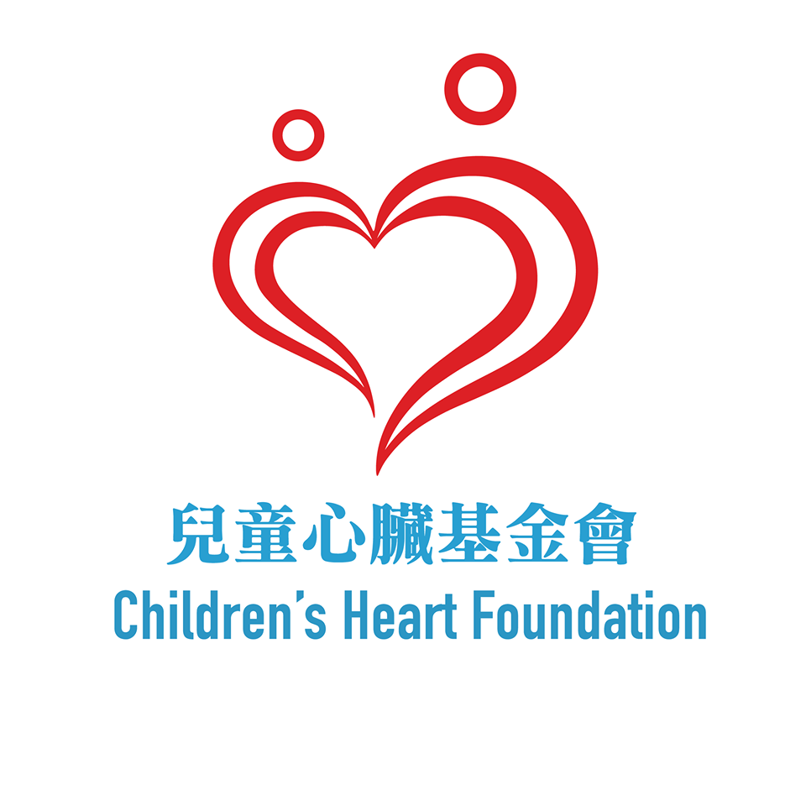
此欄由本會填寫
®登記日期：
®登記編號：
CHF 001
會 員 申 請 表 格
Membership Application Form

兒童心臟基金會會員將可定期收到本會刊物、參加各項會員活動、進一步與其他病童家屬交流及分享，免入會費。所有申請須經本會的執行委員會批核。
Members of the Children’s Heart Foundation(CHF) can receive publications and take part in CHF activities. FREE memberships. All applications are subjected to approval by the Executive Committee of the CHF.
- 會籍Membership (請選擇適當的 Please select the appropriate )
- 基本會員 Member：先天性心臟病之兒童及其直系家屬 Person with congenital heart problems and direct relatives
- 附屬會員 Associated Member：非先天性心臟病之人士 People with no congenital heart problems

- 申請人資料 Personal Particulars of Applicants
(成功登記人仕方可參加本會會員活動 Only registered members can join members activities)
姓名 (中)  Name (Chi) | 姓名 (英)  Name (Eng) | 性別  Sex | 出生日期  DOB | 心臟病患者( P/O), 如P，請列出心臟病類名稱  With Heart Disease( P/O)  Please write down the name of heart disease |  | 與心臟病患  者的關係  Relationship  請圈出最合適之關係  (Please circle the most suitable one)
 |  |  |  | P/O |  | 病人  Patient | 家長Parents | 照顧者  Carer
 |  |  |  | P/O |  | 病人  Patient | 家長Parents | 照顧者  Carer
 |  |  |  | P/O |  | 病人  Patient | 家長Parents | 照顧者  Carer
 |  |  |  | P/O |  | 病人  Patient | 家長Parents | 照顧者  Carer
 |  |  |  | P/O |  | 病人  Patient | 家長Parents | 照顧者  Carer

- 主要聯絡人資料 Main Contact information
姓名Name: (中Chi) (英Eng ) 電話Tele: 手提電話Mobile: 電郵Email:
住址Address:

- 聲明

- 本人希望收到I wish to receive
 電子版的會訊，無需郵寄印刷版予本人E-newsletter only (please provide email address)
 郵寄印刷版的會訊, (Hard copy of Newsletter ,Only a hard copy will be send to every family by mail)
- information via Whatsapp
 本人希望加入基金會家長互相Whatsapp小組分享照顧心得。
I want to participate in the CHF parents’ Whatsapp group
 不希望加入基金會家長互相Whatsapp小組分享照顧心得。
I do not want to participate in the CHF parents’ Whatsapp group
- 兒童心臟基金會盡力遵守《個人資料(私隱)條例》所列載的規定,依照收集資料時所說明的目的使用該等資料,並確保
個人資料得到妥善儲存。閣下提供予本會的個人資料(包括姓名、電話、傳真、電郵及郵寄地址等),以便日後作與 閣
下通訊、服務推廣、活動/訓練課程邀請或收集意見的用途。另外,參加者的活動相片有可能用作服務通訊、活動推 廣、服務交代等用途。
CHF undertakes to comply with the requirements of the Personal Data (Privacy) Ordinance to ensure that personal data collected are properly stored. The personal information collected (Name, telephone number, fax number, email and mailing address) may be used for the purposes of providing you with information of CHF, fundraising appeal,activities/courses invitation as well as for feedback collection and related promotion purposes
- 以上資料只作兒童心臟基金會內部用途，一切資料絕對保密。
The above information is for internal use only and will be kept confidential.

本人 口 同意上述有關使用個人資料的安排。
I agree with the above arrangement regarding the use of personal data.

IV)心臟病患者有關之資料information of members suffered from heart diseases:

A)請於下列方格內選擇合適的答案
是Yes 否No
1. 是否要接受手術/介入性導管治療? Arranging operation/ CAT?  
2. 是否需要定時服藥? Taking medicine regularly?  
3. 醫生是否贊同參與學校的體育活動? Doctor recommends PE class?  
4. 是否適合戶外活動? Suitable for outdoor activities?  

B)有否其他長期病患 是 請列出: 否
Other Chronic Disease? Yes,please list No
C)有否其他健康問題，如:發展遲緩、腦癇症. 是 請列出: 否
Other Health problem such as Developmental delay, Epilepsy？Yes,please list No
D) 是否有食物敏感? 是 請列出: 否
Any food allergy? Yes,please list No

E) 閣下及其家庭成員是否有興趣參與本會舉辦之活動? Are you interested in activities organized by the CHF
 戶外活動Outings  義務工作Voluntary Services  講座Talks
 輔導服務Counseling  心童輔導服務CHD Children Counseling
 籌款活動 Fundraising Event  互助小組Support Group
 興趣班/成長小組interest class/Developmental Group
 其他Others ______________

本人謹此聲明所提交所有文件及資料均真確無訛,本人明白故意或明知作出虛假陳述、虛報或隱瞞任何資料,將影響本人及家庭成員申請基金會服務。
I hereby declare that all the provided information is true and complete. I understand that willfully or knowing making false statement, misrepresentation or concealment of any information will make us ineligible in applying the CHF service

申請人簽署Signature of Applicant: 日期:

___________________ ____________________

